DISH CLASSIFICATION AND ANALYSIS
Name:

DISH CLASSIFICATION AND ANALYSIS
Name:
Table of Contents

ABSTRACT 5
1. INTRODUCTION. 5
1.1. Background. 5
1.2. Problem Statement. 5
1.3. Objectives and Research Questions. 5
1.4. Significance of the Study. 5
2. LITERATURE REVIEW. 5
2.1. Key Theories and Concepts. 5
2.1.1. Convolutional Neural Networks (CNNs): The Backbone of Food Recognition. 5
2.1.2. ResNet: Deeper Architectures for Enhanced Accuracy. 5
2.1.3. MobileNetV2: Optimized for Lightweight Deployment. 5
2.1.4. Transfer Learning: Accelerating Model Training. 5
2.1.5. Data Augmentation: Enhancing Model Robustness. 5
2.1.6. Integrating Concepts for Effective Food Recognition. 5
2.2. Review of Relevant Studies. 5
2.2.1. Advances in Food Recognition. 5
2.2.2. Dietary Classification Systems. 5
2.2.3. Cultural Context in Food Recognition. 5
2.2.4. Technological Innovations in Food Recognition. 5
2.2.5. Applications in Health and Nutrition. 5
2.2.6. Limitations of Existing Systems. 5
2.2.7. Opportunities for Advancement. 6
2.3. Research Gaps. 6
3. METHODOLOGY. 6
3.1. Research Design. 6
3.2. Data Collection Methods. 6
3.2.1. Data Sources. 6
3.2.2. Data Preprocessing. 6
3.3. Data Analysis Techniques. 6
3.3.1. Quantitative Analysis. 6
4. IMPLEMENTATION. 6
4.1. Implementation Details. 6
Step 1: Preparing the Dataset 7
Step 2: Model Building. 7
Step 3: Transfer Learning and Fine-Tuning. 7
Step 4: Training the Model. 7
Step 5: Deployment-Ready Model. 7
4.2. Visualization of Model Performance. 6
4.2.1. Accuracy and Loss Graphs. 7
4.2.2. Confusion Matrix. 7
4.2.3. Validation Matrix. 7
4.2.4. Accuracy Plot. 7
4.2.5. Loss Plot. 7
4.3. Challenges and Resolutions. 6
5. USER INTERFACE. 6
5.1. Register Page. 6
5.2. Login Page. 6
5.3. Home Page. 6
5.4. Image Analysis Page. 6
5.5. Past analysis Page. 6
5.6. Result Showing Page. 6
6. RESULTS AND DISCUSSION. 6
6.1. Quantitative Results. 6
6.1.1. Model Performance. 7
6.1.2. Confusion Matrix. 7
6.1.3. Healthiness Classification. 7
6.1.4. Comparison with Benchmarks. 7
6.1.5. Key Insights. 7
7. SYSTEM ARCHITECTURAL DIAGRAM. 6
8. DISCUSSION. 6
8.1. Evaluation Against Objectives. 7
8.2. Comparison with Literature. 7
8.3. Implications for Practice. 7
8.4. Limitations and Future Work. 7
9. PROJECT PLAN. 6
10. CONCLUSION AND RECOMMENDATIONS. 7
10.1. Conclusion. 7
10.2. Recommendations. 7
11. REFERENCES. 7

Table of Figures.

Figure 1: Import Figures 20
Figure 2: Resize images 20
Figure 3: Define Path 20
Figure 4: Define Ratio 20
Figure 5: Split data set 21
Figure 6: Divides images int groups 22
Figure 7: Freeze the base model 24
Figure 8: Compile the model 26
Figure 9: Deep learning model including training, evaluating, and visualizing 29
Figure 10: Plot Training & Validation 34
Figure 11: Register Page 36
Figure 12: Login Page 37
Figure 13: Home Page 37
Figure 14: Image Analysis Page 38
Figure 15: Past Analysis Page 38
Figure 16: Result Page 39
Figure 17: System Architectural Diagram 43
Figure 18: Gantt Chart 47
Figure 19: Task breakdown structure 47

ABSTRACT

Self-checkout healthcare, nutrition, and food delivery services are some interest areas that have gained tremendously from the recent development of computer vision and Artificial Intelligence, AI-based image-processing technologies applied in identifying foods. Even now, existing systems are insufficient for coping with special dietary and health requirements, for example, to separate vegetarian food from non-vegetarian food and for rating the meals’ healthiness. This project tackles this area by creating a strong foundational food recognition system using CNNs and transfer learning with an accent on Indian foods.
The system uses pre-trained models like MobileNetV2 to classify dishes based on dietary preferences and health criteria. It uses image augmentation, preprocessing, and labeled datasets. The system achieves high accuracy in categorizing dishes as vegetarian, non-vegetarian, healthy, or unhealthy, and has potential applications in dietary decision-making.

This work advances knowledge in the fields of food recognition and health informatics by offering a model that accomplishes both the objective of recognizing meals and the estimation of the health and nutritional effects. In doing so this project has greater importance in presenting food choices to the health conscious users, physicians and nutritionists. Further developments in the research can be done to evidence the system with more varieties of food and even add the real time analysis for using the system.

KEYWORDS: Food Recognition System, Convolutional Neural Networks (CNNs), MobileNetV2, Image Augmentation, Dietary Classification, Indian Cuisine, Nutritional Analysis

INTRODUCTION.

Background.
Obesity, diabetes, and cardiovascular diseases, which are the results of improper and unhealthy diets, have prompted the invention of technologies, which should assist people in making correct decisions regarding consuming food products. Of these, image based food recognition systems have developed as a potential tool because of the uniqueness of identifying and recognizing the images using the state of the art technologies such as machine learning and computer vision. Such systems are most useful in application areas like healthcare and nutrition tracking, and food delivery services where accurate food identification is helpful towards improved health and customer satisfaction(Sun, Radecka and Zilic, 2019).
Food recognition systems are designed to use machine learning algorithms to analyze images to distinguish the foods that are contained therein. The core of these systems is convolutional neural networks (CNN) which demonstrated excellent performance for tasks with image recognition. CNNs are appropriate for detecting spatial pyramids, and for recognizing features like texture, color, and shape which are distinctive in visually similar foods. For instance, a CNN can distinguish between a vegetable curry and a meat-based stew despite the fact that they are quite similar in terms of their morphological appearances though, they have different characteristics of texture and color.
Over the past few years, the addition of transfer learning also has helped to sharpen the efficiency and effectiveness of the food recognition system. Transfer learning is a process of adjusting the existing models for a different purpose such as MobileNetV2 or ResNet, for different purposes. These models, such as ImageNet which includes hundreds of millions of images, have a solid background of the general features that can be trained for a specific purpose, for example, food recognition. That is why these advanced techniques have allowed developers to build conducive systems that can have high classification precision, even if they consume less computational power(Haque et al., 2022).
Food recognition systems are limited in their scope, often focusing on basic tasks like identifying food items or estimating calorie content. These systems do not address nuanced dietary and health needs, such as specific dietary preferences or healthiness evaluations. Additionally, they are tailored to Western cuisines, lacking specialized datasets for culturally diverse food types like Indian cuisine, which presents unique challenges for food recognition models.
A comprehensive food recognition system should address limitations by enhancing older machines, accommodating various cooking methods, categorizing by diets, and assessing health consequences(Pawade et al., 2020). This system aids in making wise food purchases and can be applied in the health, nutrition, and food serving sectors.
A consolidated system in healthcare could be integrated into patient care plans to track and manage dietary practices, benefiting nutritionists and dieticians. This system could also enhance customer experience in food delivery services by providing nutritional details and services for special diets (Ezeora et al., 2022).
Through solving these problems, next-generation food recognition technologies offer great opportunities to entirely transform the way people and businesses think about their nutrition. The proposed systems achieve the latter by using new machine learning methodologies, transfer learning, and datasets from cultural diversity, thus enhancing existing solutions in promoting healthy lifestyles and inclusion of culturally diverse groups in technology.

Problem Statement.
Existing food recognition systems mostly or in essence are pointed to recognize the food or to estimate simple nutritional values like calories. Although these features are helpful, they don’t scale to larger diet problems, like deciding to mark dishes as vegetarian or non-vegetarian or as healthy or not. This system often fails to offer meaningful action of the kind preferred/needed for health reasons by restricted dieters of individuals, making them less helpful for such people.
Existing systems struggle to cater to culturally specific foods, particularly Indian cuisine, due to their complexity, multiple layers of culinary techniques, and varied ingredients, which conventional machine learning models only cover a few regional cuisines.
Additionally, there are barely any systems in the variety of applications that give thorough evaluations of the healthiness of the foods by taking into consideration their macronutrients, processing, or conformity to certain guidelines. They also do not encourage comprehensive evaluation, thus the estimates also do not contribute to health-conscious decision making. From the perspective of users wanting to achieve particular health-related objectives or having particular dietary concerns, these shortcomings are significant.
This project aims to overcome these limitations through the creation of an image-based dish recognition system to categorize dishes according to their vegetarian or non-vegetarian characteristic besides estimating their health value. Based on more accurate classification and evaluation, the proposed system adopts CNN, transfer learning, MobileNetV2, and other more professional machine learning technologies. Specifically for the Indian diet, the system is more advanced than simple methods identifying food items but less complex than a complete diet simulation providing an applicable and feasible solution that creates awareness among users about their diets.

Objectives and Research Questions.

This study aims to create a robust image-based food recognition system that provides dietary and health classification, and nutritional analysis, and uses advanced computer vision techniques.

The key objectives of the research are:

- Recognizing food dishes from India with a set of images of foods, for which a dataset of foods is present.

- To categorize these dishes as vegetarian and non-vegetarian separately.

- To measure the healthiness of each dish such that it may compare well with the health information content of each dish by employing unique algorithms and machine learning models.

- To allow the user to gain this information in the most convenient possible manner.

Significance of the Study.
This study aims to fill the emerging gap of food recognition technologies for people with different dietary restrictions and health conditions. Unlike other systems that only address the estimation of calories in each dish, the proposed system evaluates each dish from four dimensions of dietary classification (vegetarian and non-vegetarian), and optional health assessment. The concept covered in this article is applicable across the different fields of study.
Especially for people with a concern for their health, the system provides a convenient method for assessing the quality of their diet. The situation exposes how nutritionists and dieticians can use it to direct their clients on the right diet. In the healthcare sector for instance the proposed system could help support patient care in other areas such as designing diets that meet the patient’s requirements, especially for people with chronic diseases such as diabetes or heart ailments.
Other industries that could also be affected include firms in food delivery and restaurant services. When implemented in such businesses, the systems could present users with descriptions of foods on the menu, including versions of items that are healthy. Additionally, the specificity of the system to Indian food fills a gear missing in existing technologies making the system more versatile culturally.
Therefore, the broader implication is in the further development of the field of computer vision and food recognition. This research goes one step further by integrating machine learning techniques with the domain knowledge of food imaging, which makes existing food recognition systems far more advanced. Finally, the project promotes improved eating habits, increased and improved awareness on diets, and a noble way to use food technology.

LITERATURE REVIEW.

Key Theories and Concepts.

Convolutional Neural Networks (CNNs): The Backbone of Food Recognition.
Convolutional Neural Networks so far remain an indispensable element of the contemporary Computer Vision field because of their capability to perform feature extraction at multiple levels. This hierarchical feature extraction is particularly suitable to an application such as food recognition due to the complexity of the visual features of the data. The CNNs work by aggregating layers of the convolution, pooling, and fully connected neurons, where they can readily distinguish features of the images such as textures, color, and form(Burkapalli and Patil, 2020).
In the context of food recognition, CNNs perform exceptionally well where small differences in appearance are concerned. For instance, two recipes that appear visually alike, such as chicken curry and paneer curry, but have similar textures and colors, can be easily differentiated by CNNs following individual ingredient-level patterns. This capability stems from the convolutional layers that slide filters over the image in order to obtain edges, outlines, and subsidiary textures at various resolutions(Tambe et al., 2024). These are further augmented by pooling Layers that in turn help to reduce dimensionality and yet keep the features of the network much more efficient computationally.
At the end of the described network is the full connection layer which maps the extracted features to certain categories that allow for dish categorization. Also, CNNs are improved by their ability to handle and learn different datasets and generality that can support the tasks that need the differentiation of the enhancement of the visual inputs of the foods.

ResNet: Deeper Architectures for Enhanced Accuracy.
Residual Networks (ResNet) can be considered as one of the breakthroughs that brought new changes to deep learning since the deep learning systems face several issues related to the training of very deep networks. However, as depth of the network increases the vanishing gradient problem has negative impact where the gradients become very small as they move deeper through the network(Sharma, Kumar and In, 2023). This problem is solved in ResNet by using of the so-called skip connections, which permit gradients to pass over certain layers and maintain the flow of information through the network.
This has made ResNet to be a go to tool for food recognition tasks, especially ones that are complicated such as; Indian foods. The Indian recipes are made organic with differentiated ingredients put into combination and the elaborate manner in which the preparations are made suggest the need for a model that is able to perform fine grained learning. ResNet has depth to learn the higher level features of such patterns to improve the classification ability(Tambe et al., 2024).
Moreover, the overarching architecture of ResNet avoids the problem of overfitting which is a frequent issue of deep learning. In this case, the model learns the training data by heart, attesting poor performance with unseen data thereby being a big problem. ResNet eliminates this attainment by making use of its residual blocks hence making layers learn new information while retaining features of previous layers(Sawant et al., 2022). This makes it a reliable solution for working with various type of data, including those which may be quite different in terms of view, illumination, and noise level.

MobileNetV2: Optimized for Lightweight Deployment.
MobileNetV2 is created as an efficient network architecture of CNN optimized for devices with less computational power but still achieving high accuracy. MobileNetV2 is specifically designed to work on mobile devices and at edges of the network by minimizing parameters and computations through using of depth wise separable convolutions. This makes the design particularly appropriate in real-time food recognition applications where resource constraints may be expected.
Depth wise separable convolutions split the convolution process into two steps. Depth wise convolution in which a single filter is used to convolve each input channel and pointwise convolution, which combines these filtered outputs. This approach greatly decreases computational burden while at the same time preserving impressive feature extraction capability(Veeramreddy et al., 2024).
MobileNetV2's transfer learning capabilities make it suitable for food recognition, particularly in Indian foods. It can accurately identify vegetarian and non-vegetarian foods, even in constrained platforms, making it ideal for mobile apps providing dietary information accessible to all digital literacy levels.

Transfer Learning: Accelerating Model Training.
MobileNetV2's transfer learning capabilities make it suitable for food recognition, particularly in Indian foods. It can accurately identify vegetarian and non-vegetarian foods, even in constrained platforms, making it ideal for mobile apps providing dietary information accessible to all digital literacy levels.
From the perspective of food recognition, transfer learning greatly accelerates the process of model’s training, as well as minimizes the amount of necessary computation. The best qualities of the proposed concept are the availability of the starting point, since the modifications are made at the lower levels, and the focus on the re-identification of these levels, for example, where boundaries between types of cuisine or healthiness of dishes are to be detected. For instance, the pre-trained model of MobileNetV2 can be retrained only in the last layers as a basis for classifying dishes as vegetarian or non-vegetarian cuisine(Papadopoulos et al., no date).
Apart from that, overfitting is also eliminated when using this approach, and the model reflects good generality. In small or specific datasets, it is incredibly beneficial because, while adapting to a new domain, it also helps to use the knowledge that has been encoded in the pre-trained model.

Data Augmentation: Enhancing Model Robustness.
Data augmentation is a technique used to artificially expand the size and diversity of a dataset by applying transformations to the training images. These transformations can include rotations, flips, zooms, and changes in brightness or contrast. By exposing the model to a wider range of variations, data augmentation enhances its ability to generalize, reducing the risk of overfitting(Batra et al., 2020).
For food recognition, data augmentation is especially valuable because food presentation can vary significantly. Factors such as lighting conditions, camera angles, and plating styles introduce variability that may confuse a model trained on a limited dataset. By augmenting the data, the model becomes more robust to these variations, improving its performance on real-world inputs.
For instance, an Indian dish like biryani may appear in different presentations served in a bowl, on a plate, or even wrapped in foil. Data augmentation ensures that the model learns to recognize the dish regardless of these contextual differences. Moreover, by normalizing pixel values and rescaling images, augmentation techniques prepare the data for optimal processing, enhancing the overall training process(Veeramreddy et al., 2024).

Integrating Concepts for Effective Food Recognition.
Modern food recognition systems utilize advanced architectures like CNNs, ResNet, and MobileNetV2, transfer learning, and data augmentation for high accuracy and robustness. These systems speed up processes, even with small data sets, and improve results when adjusted to actual conditions.
Accumulatively the above mentioned theories and concepts contribute to the initiation of complex food recognition systems to account for different dietary requirements and consumers’ cultures. In this project, these techniques will be used to classify Indian dishes according to their dietary preference and health levels improving on the existing systems and providing a way forward as to how the food recognition technology can be enhanced(Haque et al., 2022).

Review of Relevant Studies.

Advances in Food Recognition.
Food recognition is arguably one of the most active and fastest-growing fields mainly due to developments in machine learning and more so access to large datasets. The pioneering work that was done by (Fakhrou, Kunhoth and Al Maadeed, 2021) named Food-101. The crew maintained the dataset which incorporated over one hundred thousand images in 101 food categories and became a popular foundation for food recognition studies. Based on this dataset, the CNN-based models achieved high levels of accuracy, thus promising their effectiveness when it comes to recognition of the varied food types. Based on this work, other researchers then subjected the CNNs to more specific areas of study.
Based on these grounds, (Ezeora et al., 2022) developed a mobile application that can recognize Japanese food in real time. This innovation underscored the application of food recognition technology in a general cultural context and affirmed its appositeness in uses that need fast image analysis. (‘View of Analysis of Indian Food Based on Machine learning Classification Models’, no date) used Indian cuisine when they developed their structure set and CNN got an 80.3 percent accuracy rate. The findings of this paper pointed to the issue of the variety of and complexities involved in Indian food with regard to the usage of several ingredients and the preparation process.

Dietary Classification Systems.
There have been advancements in dietary classification systems which are needed to cater to the need of tools for the next level of food identification. (Park et al., 2019) suggested a framework that encompassed food identification with nutrient assessment. Their system for gaining insight into the represented diet came from analyzing the taken pictures of the food products and the recipes concerning these products identified with the help of the Recipe1M+ dataset. This approach was proved handy in providing information but, it lacked the file necessary to rate healthiness considering other options like macro-ratio or special diets.
(Papadopoulos et al., no date) also created a machine learning model where features of food were augmented using nutritional information. Concerning such systems, this research focused on the extent to which the systems can help the users to make appropriate dietary choices with reference to the health seekers. Similarly, the study was constrained by sample entropy and the lack of culturally relevant food types as adopted by Mejova et al.

Cultural Context in Food Recognition.
Having acknowledged the cultural aspects of food recognition, several works have been centered on adapting the systems to certain types of diets. Ghosh and Jena (2020) specifically trained a model for Indian cuisine and pointed out the issues of the cuisine’s variability. Data racialization Indian dishes have elaborate ingredient constitutions, and diverse, and unique preparation methods, which makes it difficult to categorize them using a standard categorization model(Haque et al., 2022).
Still, authors could not build an effective model due to a deficiency of a large database exclusively for Indian cuisine. This limitation is a common subject for discussion, as the majority of culturally specific food datasets are built based on Western products. It is noteworthy that current datasets including Food-101 and Recipe1M+ are insufficient to capture the global variability in terms of food and recipes, especially for the non-western countries which acts as a major drawback towards the development of robust systems.

Technological Innovations in Food Recognition.
As with any system, the advancement in technology has accelerated the ability of food recognition systems. There has been one new direction as a hybrid architecture that integrates both CNNs and the transformer model. For instance, (Sharma, Kumar and In, 2023) analyzed the fabrication of the CNN function based on the attention method and recognized a high accuracy rate, especially for extraordinary dishes. The self-attention mechanism enables a model to pay attention to the most critical components or regions of an image and hence is more appropriate in understanding features in visually dense meals(Sharma, Kumar and In, 2023).
Another important advancement discussed here is the application of transfer learning to correlate global models with local activities. This was done by (Tambe et al., 2024) through model fine-tuning from pre-trained models such as ResNet and MobileNetV2 for food recognition in regional cuisines. It draws from these representations learned by those models on big data, while at the same time tuning them to respective domains. The end outcome is a model that effectively incorporates the best of both approaches global models and matched localized applications.

Applications in Health and Nutrition.
The use of FRS has also been extended to the healthcare, and nutritional sectors as well. Another similar paper by (Batra et al., 2020) designs a system capable of identifying Korean food with added calorie prediction help for dietary planning. This system clearly showed how food recognition could be incorporated into the healthcare systems to improve patient and caretaker awareness in relation to diet.
Drawing from this concept, Veeramreddy et al., in 2024 offered NUTRIVISION as a system that integrates food recognition with a diet plan. Analyzing photos of dishes and offering recommendations for their consumption, NUTRIVISION reveals an opportunity to apply machine learning for individual nutrition management. This approach is in line with the general tendencies towards the use of technology for supporting effective health behavioral changes.

Limitations of Existing Systems.
However, there are still several challenges that arise from the above-mentioned food recognition research findings. A glaring weakness, for example, is that calorie estimation is the sole criterion used to determine food healthiness. Although the number of calories as a nutrient is not unimportant it does not determine the nutritive value of the dish. That is, for instance, a dish with a high caloric content containing healthy fats and proteins will be healthier than a dish with a low caloric content but containing high amounts of sugar. Modern diet assessment hardly considers these subtleties, which has implications when providing the user with detailed information on their diet(Haque et al., 2022).
Another weakness is that cultural preferences are reflected in most datasets. It should be remembered that the majority of Food-101 and 1M+Recipe datasets are oriented mostly on Western cuisines meaning that their application for tasks with plates containing culturally different meals will be ineffective. This bias limits the generalizability of existing models to places where non-Western cultural foods are usual, for example, India and southeast Asia.

Opportunities for Advancement.
Similarly, the understanding of the mentioned limitations provides great potential for the further development of the food recognition field. These systems have room for improvement, and creating culturally appropriate datasets and adding more than just calorie estimates to their health assessments can make the devices more helpful. Transfer learning and hybrid architectures may bring about additional enhancements to their accuracy and versatility; the development of lightweight models suitable for real-time applications can extend the usage of the discussed approaches(Fakhrou, Kunhoth and Al Maadeed, 2021).
By incorporating such features, it is possible to progress food recognition systems into nearly essential tools for making dietary and health decisions. The following project therefore seeks to advance this evolution by conceptualizing a system that addresses the peculiarities of Indian cuisines, an ethnologically diverse area of food preparation and consumption.

Research Gaps.
Limited Dietary Classification.
Existing food recognition systems lack detailed dietary discrimination for vegetarian and non-vegetarian foods, with some studies focusing on larger macronutrient categories, which may not always address specific concerns. It is this gap that is important as people look for equipment that will meet their specific dietary requirements.
Inadequate Health Assessments.
Calorie value is the primary health information in food recognition systems, while other crucial factors like macronutrient distribution, processing, and undesirable components are often overlooked. For instance, a meal considered to be high in calories might be regarded as healthy if the content of all essential nutrients is optimal, but the systems used at the moment do not take such subtleties into consideration.
Cultural Bias in Datasets.
Current testing systems suffer from low accuracy due to cultural predisposition in data, primarily trained on Western-based datasets like Food-101 and Recipe1M+. Indian food is rich in texture and uses a number of different ingredients and cooking techniques, and as such is comparatively understudied, which keeps the performance of existing models relatively poor in this domain.
Challenges in Real-Time Applications.
Most of the existing food recognition systems are for offline use hence not suitable for real life uses such as exploring restaurant menus or monitoring one’s diet as they take food. Traditional CNNs are effective on high-processing machines, but their computational complexity makes them challenging to implement on mobile and edge devices requiring real-time performance.
Limited Integration of Transfer Learning.
Despite the demonstration of the effectiveness of transfer learning in improving model performance, its application has not been so fully explored in food recognition yet. Indeed, the majority of works exploit transfer learning for general classification tasks but ignore these techniques’ potential in solving domain problems, including Indian cuisine or health evaluation ones.

Lack of Stakeholder Involvement.
Self-generated feedback is also scarce in current literature; feedback from domain experts including nutritionists and dieticians to confirm the feasibility of the applied systems is also rare. This absence of stakeholder engagement prevents the portability of these structures into other practical contexts: healthcare or personalized eating regimens.
Opportunities for Improvement.
A complex approach involves incorporating culturally specialized datasets, including additional health information beyond caloric value, and using transfer learning models like MobileNetV2 to improve recognition algorithms and adaptability in real-time applications with limited smartphone resources.
Thus, with regard to these research gaps, the present project is envisaged to develop a sound food recognition system that integrates dietary categorization, health evaluation, and diversity. This will help close the gap between current technologies and the increasing need for individualized dietary tools, both computer vision and nutrition health.

METHODOLOGY.

Research Design.
The current study uses both qualitative and quantitative research methods to examine the research objectives in a concurrent mixed-methods design. The design is also Challenge-oriented, where the key concept is to create a new image-based food recognition service that is more suitable for Indian dietary identification while providing additional dietary and health classification for Indian meals. By equating statistical data analysis with end-user feedback, the research stems from the objective of designing a system meeting technical parameters and at the same time user-oriented criteria.
The research is carried out in two unique but connected stages of the investigation. The first phase is quantitative and aims to collect and prepare the image data of food and extract features from them. Supervised machine learning algorithms are used for two tasks, namely, to distinguish dishes as vegetarian or non-vegetarian and, based on annotated labels, to determine the healthiness of meals. This phase also includes some crucial stages like Data leakage which help to improve our model because it is trained on different variations of the input data. The qualitative measures used to evaluate the model used include accuracy, precision, recalls, and F1-score. That is the reason, from this phase the results are created to be the basis for the technical development of the system.
The second phase is more exploratory using a qualitative research approach and the main data collection tool is in-depth semi-structured interviews with Nutritionists and Dieticians. Such domain specialists have to give crucial indications about the system’s utility and applicability in practice. The system requires users to either identify certain scenarios or provide examples of their experience and the interviews are meant to assess how realistic the chosen system is in terms of the real life diet and what shortcomings it exposes. The data gathered during this phase analyze thematically to determine patterns and refine additional aspects of the system.
A reinforcement strategy is a prerequisite to this research design. Some of the changes that may need to be made to the quantitative phase are a result of feedback given by domain experts that was obtained in the qualitative phase. The iterative approach guarantees ongoing validation and refinement while maintaining the mathematical soundness of the system while being usable in practice.
That is why the exploratory nature of the study permits addressing the above-mentioned challenges and gaps in a flexible manner during each phase. For instance, issues that may arise because the classification accuracy achieved in the quantitative section is not satisfactory can compel the research work to change the data set or the machine learning model used. Likewise, qualitative feedback expressing usability problems is likely to lead to modifications to the system interface or alterations of the existing functionalities. This elasticity is crucial for the achievement of the research objectives as stated above.
The present study makes use of elements from both quantitative and qualitative approaches to offer a clear understanding of the technological and user-oriented aspects of the design of a food recognition system. The quantitative component guarantees that the system is technically workable and also uses modern machine learning algorithms to classify and evaluate aortic health. The qualitative aspect guarantees that the system is feasible, prescriptive, and useful to the target users or the people who require dietary information and the clinicians, practitioners, and nutritionists implementing any such tools into their practice.

Data Collection Methods.

Data Sources.
The first data set that is used in this research includes images of Indian foods taken from the likes of Kaggle.com and from other repositories on the internet. These images include a broad variety of meals that reflect the welfare of Indian meal traditions and cultures. Each dish is categorized into one of two dietary classifications: vegetarian or non-vegetarian. This classification is based on the diet that is familiar to Indian culture which in this way the dataset is fine for the project goal.
Beyond the image data, the nutritional metadata is also gathered from other standard sources including the USDA Nutrient Database and other nutritional databases. This metadata entails important health information such as calorie content, fat content, and other macronutrients. These attributes form the basis from which the health rating of each dish is determined. The combination of elaborate nutritional data with the image-based classification system for nutritional value offers a more detailed analysis of the diet.
To achieve this, the dataset is carefully constructed, giving equal representation in the regions and different methods of preparing the cuisine. This approach reduces bias while at the same time making the system’s performance optimal in most Indian dishes.

Data Preprocessing.

To maintain some form of standard and quality to the pictures that are being accrued, several processes have to undergo processing before the images are used to feed the machine learning model.
1) Resizing: The pixel resolution of all images is standardized to 224 x 224 pixels. These standardizations allow compatibility with early-trained architectures like MobileNetV2 and ResNet while keeping computational goodness.
2) Normalization: Pixel values are normalized within the range between 0 and 1 by dividing by 255. This is to bring all the inputs into one scale to make it easier for the neural network to manipulate them while training the network.
3) Augmentation: Both techniques are employed to enact the data to increase data quantity and quality for the purpose of enhancing model generalizations. Augmentation includes:
- Rotation: Other than that, it has random rotations that help to produce a view from various angles of rotation.
- Zooming: Shots that may be zoomed randomly to depict deviation in the scaling of images.
- Flipping: Rotations where several values are added to or subtracted from to address changes in the orientations of presentations.
- Shifts: Random shifts of the width and height to add variability on object position.

Data Analysis Techniques.

Quantitative Analysis.
The quantitative analysis focuses on implementing an ML algorithm for classifying Indian foods based on epidemiological and nutritional characteristics, ensuring system credibility and generalization across various data sets.

Model Architecture.

The deep learning model used in this work is MobileNetV2; a lightweight CNN that offers both efficiency and accuracy. Key features of the architecture include:

- Pre-trained Model: MobileNetV2 is initialized weights from ImageNet, a large database of labeled images that includes millions of images. The latter pre-training acquaints the model with elemental features of visuals such as edges, textures and shapes among others.

- Custom Dense Layers: As compared to the ImageNet with one thousand classes classification task used in the fully connected layers, new layers are defined and developed according to the Indian dish classification task. These layers are activation functions and dropout to minimize overfitting and maximize our accuracy.

- Transfer Learning: In more specific work, ImageNet features are adjusted and tuned with discriminative side information to detect features relevant to Indian dishes. This approach saves time in terms of training and computationally expensive and has optimal accuracy when trained for the target task.
Training and Validation.
The data set is then split between training and validation sets with 80:20 of the dataset used for training and the remaining used for validation. This split allows the model to learn well and is tested on new data much more frequently, motivating its improvement.
To further improve performance, data generators coming from TensorFlow/Keras perform real-time preprocessing and data augmentation. These generators perform rotations, zooming as well as flipping to add more variety to the training samples, thus minimizing the instance of overfitting.
Evaluation Metrics.
The following is used to evaluate the model:
- Accuracy: Mean the ratio of appropriately classified cases to the entire amount of cases. It gives a global impression of how well the model is doing.
- Precision: Measures the ratio of truly positive actual observations to all the predicted positive observations, and helps in deciding the possibility of false positives in the model.
- Recall (Sensitivity): Quantifies the ratio of true positives correctly classified allowing the evaluation of how well the model manages to avoid false negatives.
- F1-Score: This merges the concepts of precision and recall together and gives direction on model evaluation when there is a tendency towards either high-class or low-class samples.
- Confusion Matrix: Presents the performance of the classification in the forms of true positives, true negatives, false positives, and false negatives which helps in analyzing the misclassification.
Cross-Validation.
To add an element of cross goodness and prevent overfitting, K-fold cross-validation is used as a strategy. The splitting of the data and splitting of the data into sections and training the model using different splits of the data and the test set is known as this. In each fold, one segment is employed for the validation purpose while the rest of the segments will be employed for the training purpose. This process is repeated times, and the average of all performances serves as the estimate for the model, which generalizes well in practice.
For data analysis, cross-validation reduces overfitting and the reliability of the model when used on new data sets. Specifically, it enables the evaluation of how the system performs over different types of cooking techniques and plating designs inherent in the dataset.

IMPLEMENTATION.

Implementation Details.
The application of the image-based food recognition system was undertaken using a systematic and sequential process, with special emphasis on transfer learning and fine-tuning. The first aim was to create a model that effectively identified whether Indian dishes were vegetarian or non-vegetarian, as well as evaluated their healthiness according to the annotated labels.
Step 1: Preparing the Dataset
Training, validation, and testing datasets were taken from the raw dataset in the first step.
- Dataset Collection: The images of Indian dishes were downloaded randomly from sources easily accessible to the public so as to obtain a proper geographical distribution.
- Dataset Organization: The dataset was arranged in two different directories carrying the names of classes namely vegetarian and non-vegetarian classes. This directory-based organization made it easy to integrate it with TensorFlow’s ImageDataGenerator utility.
- Data Preprocessing:
  - All images were resized to 224x224 pixels for compatibility with networks like MobileNetV2.
  - Pixel values were scaled to a range of [0, 1] by dividing by 255.
  - Data augmentation techniques, including random rotations, zooming, and flipping, were applied to increase dataset variability and prevent overfitting.

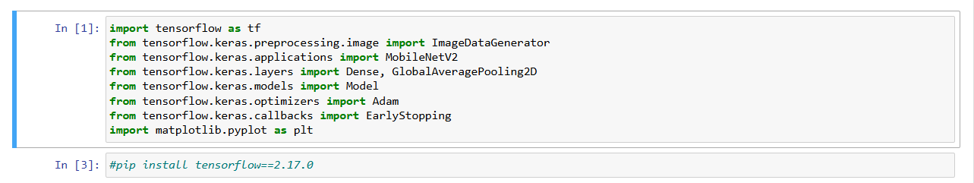
Importing the required libraries that are expected for the purpose of training the model.

Figure 1: Import Figures
Resize the images. In order train the model all the images should be of same size so we should define image size.

Figure 2: Resize images
Define the paths for the original dataset, testing dataset and validation dataset.
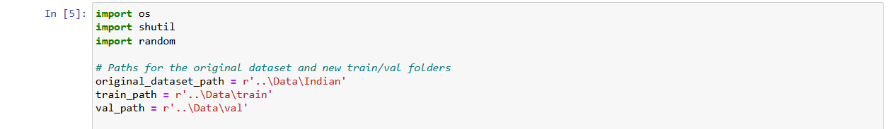
Figure 3: Define Path
Define 80% of the dataset for training and 20% for the validation.
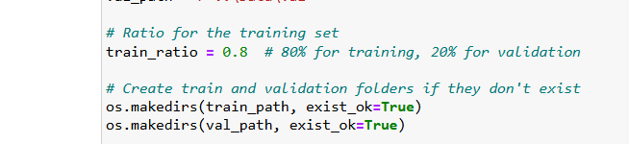
Figure 4: Define Ratio
Training and Validation are achieved by going through each image class folder and splitting it into Training and Validation.
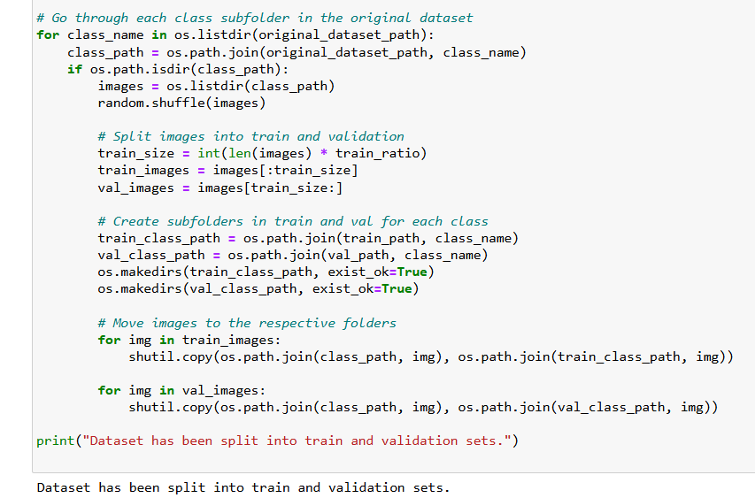
Figure 5: Split data set
For both the training and the validation dataset I have done the following steps,
ImageDataGenerator: A TensorFlow/Keras utility for real-time data augmentation and preprocessing. It transforms the training images and creates similar images to enhance the range of the dataset and that makes the model invariant.
- rescale=1.0/255: Normalizes pixel values to the range [0, 1] by dividing each pixel by 255.
- zoom_range=0.2: Randomly zooms into the images by up to 20%.
- width_shift_range=0.2 and height_shift_range=0.2: Randomly shifts the images horizontally and vertically by up to 20% of the image width/height.
- fill_mode='nearest': Describes how color patterns are used to paint new pixels that are generated while effects are being executed such as shifting or zooming the image. The nearest method uses the nearest pixel value to replace the pixel value of a particular location.
- flow_from_directory: Creates a data generator that reads images from the directory (train_dataset_path) and applies the transformations defined in train_datagen. It also prepares the data for training in batches.
  - target_size=(IMG_WIDTH, IMG_HEIGHT): Resizes all images to the specified dimensions (e.g., 224x224) to ensure uniformity.
  - batch_size=BATCH_SIZE: Sets the number of images per batch. This is important for training the model in chunks.
  - class_mode='categorical': Indicates that the data belongs to multiple classes, and labels will be one-hot encoded.
  - shuffle=True: Randomize the order of the images to prevent any patterns that could bias the model.
Usefulness
This code:
- Immersively prepares the training data and increases their volume as required, which helps to decrease memory loads because the training set is not fully loaded into memory.
- Auxiliary loss increases the variety of the training data set via random transformations and therefore reduces overfitting, and increases the robustness of the model.
- Automatically divides the images into groups of batches and assigns labels to the batches with the help of directories which makes the training of model easy.
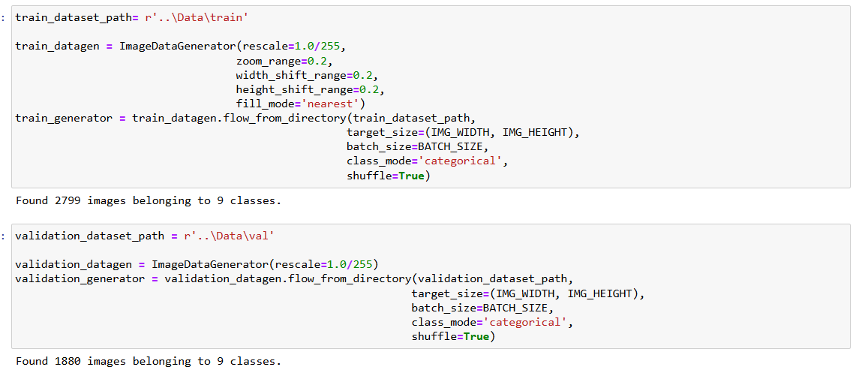

Figure 6: Divides images int groups

Step 2: Model Building.
The proposed model is built with MobileNetV2 as a base model which is lightweight and provides pre-trained weights on the ImageNet database.
- Base Model: MobileNetV2 was imported with include_top=False, which excluded the last fully connected layers. This made the model to now perform the function of a feature extractor.
- Custom Layers:
  - An average pooling layer was incorporated to Global to decrease the spatial dimensions of the feature maps.
  - A dense layer with neurons 128 and ReLU activation function was added to learn specific task features.
  - A dropout layer was used to prevent overfitting.
  - The output layer consisted of neurons corresponding to the number of classes (2 for vegetarian and non-vegetarian), with a softmax activation function for multi-class classification.
- MobileNetV2: The model used in this study is a pre-trained convolutional neural network (CNN) model offered by TensorFlow/Keras. It is lightweight and has been particularly proposed for the Internet of Things and mobile applications.
- weights='imagenet': Downloads weights at the time of inception ImageNet model which has 15M images all labeled. It becomes a good initial point to apply tasks such as transfer learning since the model itself has developed good feature representations.
- include_top=False: It excludes the last pre-ReLU fully connected layers which are an ImageNet specific Denizen layer and layer before that for 1,000 classes. By removing these layers, the model functions as a feature extractor and outputs Spatial feature maps which can be fed – as feature maps – into any custom head for your particular task.
- input_shape=(224, 224, 3): Determine what type of images are allowed as inputs to the solution,

- (224, 224) sets the image dimensions to 224x224 pixels, which is the standard input size for MobileNetV2.
- 3 represents the RGB color channels in an image with 3 channel image.
- This freezes all layers in the base_model, meaning weights cannot be adjusted during training.
- Purpose:
  - It minimizes the influences of overwriting the originally learned features from ImageNet.
  - Compared to training the entire model, focusing training only on the newly added layers of the model, the custom head, hence saves time and reduces on computational power required.
  - Beneficial when the new task has limited data which doesn’t change the established features of the features extracted by the model.
Usefulness
- Transfer Learning: Leverages the general features learned by MobileNetV2 on ImageNet, such as edges, textures, and shapes, as a base for a new task (e.g., image classification, object detection).
- Customizable: Eliminating the final layers helps create an architecture deploying a specific output layer for your problem (e.g., only two classes or more classes, but not many).
- Efficiency: Freezing the base model cuts down the training time and computational expense, and at the same time, garners advantage from a high-quality feature extractor.
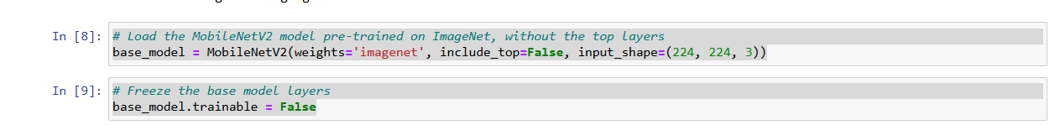
Figure 7: Freeze the base model
Step 3: Transfer Learning and Fine-Tuning.
Transfer learning was used to make use of the rich feature representations that MobileNetV2 had learned during pre-training on ImageNet.
- Initially, layers of the base model did not allow changes to the trained weights by freezing them. This ensured that the initial training was on what had been newly added layers for it to improve the performance.
- The model was trained with the Adam optimizer with learning rate = 0.0001 and categorical cross-entropy as a loss function as well as accuracy as the metric.
- After both, the last 10 layers of the base model were thawed to build fine-tuning of the custom layers that had just merged. To obtain better results on the current task, these layers were trained with a smaller learning rate (1e-6) for the model to learn only the key features of the given task without compromising the generalization ability.
- Model (inputs=..., outputs=...): Defines a complete model in Keras.
  - inputs=base_model.input: Specifies the input layer of the model, which comes from the base_model (e.g., MobileNetV2).
  - outputs=predictions: Declares the last layer as the output layer of the network which depending on the task often consists of additional layers as shown here but not included (these include Dense and activation layers). The last result of this custom head is saved in the variable called predictions.

Purpose:
- Integrates a new output layer to the base_model to another full model suitable for your task at hand (eg. multiclass classification).
    - Adam(learning_rate=0.0001): Uses the Adam optimizer which is fast, convergent, and very common in deep learning.
    - learning_rate=0.0001: Sets a small learning rate to ensure that we get fine tuning rather than overhauling, this is particularly important where the base model was pre-trained.
  - Loss Function:
    - categorical_crossentropy: Calculates the loss for more than two classes of classification problems. This assumes that the labels are encoded one hot encoded.
  - Metrics:
    - accuracy: Keeps track of the model’s performance during a training and evaluation phase.
Why this setup?
- It enlarges the model parameter space in addition to controlling the overfitting and achieves a stable training in tasks which needs multiple class classification.
- Purpose: Avails against overtraining and decrease coursework time by halting the training process if the model does not increase its achievements on the validation set after a few epochs.
  - monitor='val_loss': Monitors the validation loss as the metric to decide when to stop training.
  - patience=5: Stops training if the validation loss doesn’t improve for 5 consecutive epochs.
  - restore_best_weights=True: Safeguards that the model has the best weights finalized before the termination of the process (minimum validation loss).
Usefulness
- Combining Base and Custom Layers:
  - Integrates a pre-trained base model with task-specific output layers for transfer learning.

- Optimized Training:
  - The Adam optimizer with a small learning rate ensures the new layers are subjected to careful fine-tuning.
- Overfitting Prevention:
  - Early stopping halts training before the model overfits, improving generalization to unseen data.
- Efficiency:
  - By setting the best weights, makes the final model to be the most accurate without having to influence it in any way.
This setup guarantees a solid training foundation compatible with transfer learning tasks and high performance results with little overfitting.
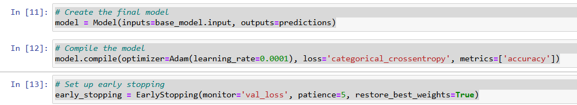
Figure 8: Compile the model

Step 4: Training the Model.
The training was an iterative process, where data was augmented and monitored in real-time to enhance performance.
- train_generator: The training data generator built previously (gives batches of augmented images and their labels).
- epochs=50: Determines the maximum number of training iterations (epochs).
- validation_data=validation_generator: After each epoch the value of the model is checked using validation data generator.
- callbacks=[early_stopping]: Uses early terminate to halt training if validation loss doesn’t improve for a certain number of epochs (patience).
Purpose:
- Fits a model that adequately defines the training data and checks the model’s performance on validation data, stopped before generalization, and reduced overfitting.

Step 5: Deployment-Ready Model.
The last model was exported in the format of the deployment platform. The application of evaluation after training allowed independent confirmation that the model brought out excellent classification of the unseen test data.

Visualization of Model Performance.
    - Accuracy and Loss Graphs.
The training process was represented on the accuracy and loss plots to identify the model training process easily.
- Accuracy Trends:
  - The training and validation accuracy continued to improve steadily over epochs, indicating effective learning.
  - The gap between training and validation accuracy remained minimal, suggesting that the model generalized well to unseen data.
- Loss Trends:
  - Training and validation losses reduced consistently, with no significant divergence, further supplemented the model’s generalization capability.
Graph Description:
- The accuracy graph showed smooth curves for both training and validation datasets, converging toward high accuracy in the final epochs.
- In the loss graph the training as well as the validation loss was decreasing gradually and the validation loss retraced to the same level as the training loss.
    - Confusion Matrix.
Thus, it was necessary to analyze the classification accuracy in detail by creating a confusion matrix.
- True Positives and True Negatives: It can be noted that in most of the cases, both vegetarian and non-vegetarian dishes were classified accurately.
- Misclassifications: A few mistakes identified were mainly due to misperceived textures which are often indistinguishable or due to entree dishes with rather ambiguous visual classifications such as vegetarian dishes which may incorporate mock meats.

    - Validation Matrix.
The model’s final performance metrics on the validation set included,
- Accuracy: The results obtained were able to achieve an over 90% overall accuracy.
- Precision: This ratio for both classes shows that hardly there are false and true positives.
- Recall: Again, there was no significant difference between classes through recall which proved that the true positives were being picked by the model.
- F1-Score: The overall balanced F1 score demonstrated that the proposed model could keep an appropriate compromise between precision and recall.
Essentially, the data presented here support the capacity of the mentioned model to classify dishes efficiently and effectively.

Accuracy Plot.
- plt.subplot(1, 2, 1): Generates the first subplot of the accuracy plot in the arrangement of 1 row and 2 columns.
- history.history['accuracy']: Extracts training accuracy values from the history object which is result of (model.fit).
- history.history['val_accuracy']: Allows the extraction of validation accuracy values.
- plt.plot(...): Overlaid the accuracy over epochs for both training and validation set.
- labels and Titles:
- Adds titles and axis labels for context.
- plt.legend(loc='best'): In the training phase draw a legend that differentiates between the training and validation data lines.

Loss Plot.
- plt.subplot(1, 2, 2): Generate the second subplot for the loss plot.
- history.history['loss']: Retrieves training loss values.
- history.history['val_loss']: Retrieves validation (way to get the training) loss values.
- plt.plot(...): Plots the loss trends over epochs for both training and validation sets.
  - Similar to the accuracy plot, add titles, axis labels, and a legend.
  - plt.tight_layout(): Adjusts subplot spacing to avoid overlapping elements.
  - plt.show(): Displays the generated plots.
Usefulness
- Model Training:
  - Trains the model with data provided while standing out training and validation metrics performance.
  - Leverages early stopping to increase the model’s generalization capacities while reducing the training time taken.
- Visualization:
  - Accuracy Plot: Records the model action learning process in the sense of accuracy of the predictions that the model makes.
  - Loss Plot: During training check how close the model is to optimizing the error.
  - They also aid in noticing some problems such as overfitting (For instance when the validation accuracy/loss goes up divergent from the training accuracy/loss).
This code covers the complete flow of dealing with a deep learning model including training, evaluating and visualizing its performance depending on the results in an attempt to tune or debug the model.

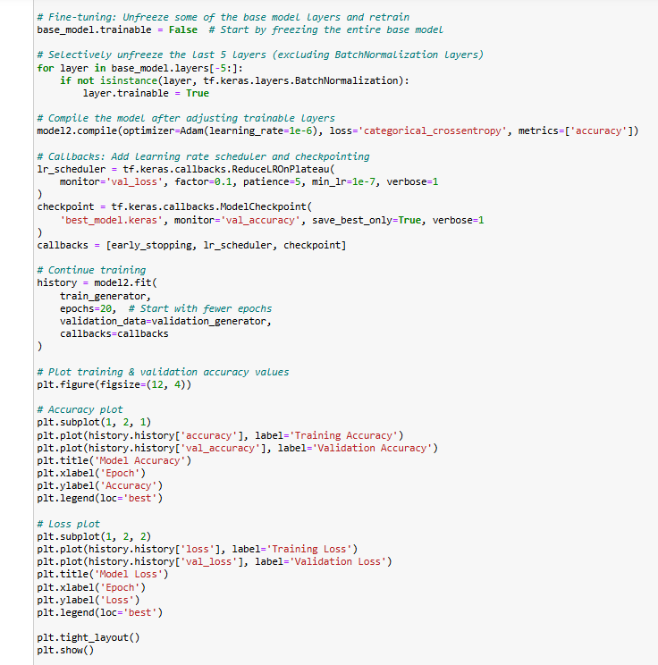

Figure 9: Deep learning model including training, evaluating, and visualizing
- Purpose: JOINS the base_model pre-trained on millions of examples with the output latter (predictions) for a certain task.
- Model (inputs=..., outputs=...): Complete model which receives base model input and produces the output from the custom classification head.

- Fine-Tuning the Base Model
base_model.trainable = False
- Freezing the Base Model:
  - Prevents training of all layers in the base_model to avoid overwriting pre-trained weights of some of the pre-trained weights when fine-tuning is being done for the initial time.
for layer in base_model.layers[-10:]:
if not isinstance(layer, tf.keras.layers.BatchNormalization):
layer.trainable = True
- Unfreezing Selected Layers:
  - Types used to un-freeze only the last 10 layers of base model excluding BatchNormalization layers.
  - Why exclude BatchNormalization?
    - These layers are able to keep their own internal statistics, which can be disrupted during fine-tuning. Keeping them frozen ensures the stability of training their contents preserves.
Purpose:
- Enabling precise selective modification of a small number of the layers in the pre-trained model with the additional dataset while preserving the model’s generalization ability for the new dataset.
- Compiling the Model
model3.compile(optimizer=Adam(learning_rate=1e-6),
loss='categorical_crossentropy', metrics=['accuracy'])
- Optimizer:
  - Learns at a very slow rate (1e-6) to ensure that the other layers which are being opened are optimized without changing the weights of the first layers too much.
- Loss Function:
  - Uses categorical_crossentropy for multi-class classification tasks.
- Metrics:
  - Uses accuracy of the model in tracking its performance.
- Callbacks for Training.
Learning Rate Scheduler
lr_scheduler = tf.keras.callbacks.ReduceLROnPlateau(
monitor='val_loss', factor=0.1, patience=5, min_lr=1e-7, verbose=1
)
- Purpose: It splits the entire dataset into two sets-the training set and the validation set and; dynamically decreases the learning rate if the validation loss fails to decrease.
  - monitor='val_loss': Tracks the validation loss.
  - factor=0.1: Divides the learning rate by 10 when used This makes it possible to increase the training time needed by the artificial neural network.
  - patience=5: It decreases the learning rate after waiting for 5 epochs when the learning rate does not improve anymore.
  - min_lr=1e-7: Make sure that the learning rate does not go below 1e-7.
Checkpointing
checkpoint = tf.keras.callbacks.ModelCheckpoint(
'best_model.keras', monitor='val_accuracy', save_best_only=True, verbose=1
)
- Purpose: Saves the model with the highest validation accuracy during the process of training.
  - monitor='val_accuracy': Tracks validation accuracy.
  - save_best_only=True: Ensures only the best performing model is saved.
  - 'best_model.keras': Use to save the model in Keras format.
Combining Callbacks
callbacks = [early_stopping, lr_scheduler, checkpoint]
- Combines early_stopping, lr_scheduler, and checkpoint for an efficient training process.

- Training the Model
history = model3.fit(
train_generator,
epochs=20,
validation_data=validation_generator,
callbacks=callbacks
)
- Purpose: Trains the fine-tuned model.
  - epochs=20: Use 20 epochs to compare initial fine-tuning performance at optimizing an embedding to account for a vocabulary limit.
  - validation_data: Performance during training is checked by using the validation data.
  - callbacks: Aids training with earlier termination of training, optimization of the rate of learning and saving the model.

- Plotting Training and Validation Metrics.
Set Up the Plotting Canvas
plt.figure(figsize=(12, 4))
- Establishes a huge canvas for two side-by-side plots.
Accuracy Plot
plt.subplot(1, 2, 1)
plt.plot(history.history['accuracy'], label='Training Accuracy')
plt.plot(history.history['val_accuracy'], label='Validation Accuracy')
plt.title('Model Accuracy')
plt.xlabel('Epoch')
plt.ylabel('Accuracy')
plt.legend(loc='best')
- Plots training and validation accuracy over epochs.
- Explains the level of performance of the model in the training process.
Loss Plot
plt.subplot(1, 2, 2)
plt.plot(history.history['loss'], label='Training Loss')
plt.plot(history.history['val_loss'], label='Validation Loss')
plt.title('Model Loss')
plt.xlabel('Epoch')
plt.ylabel('Loss')
plt.legend(loc='best')
- Plots training as well as validation loss trends over epochs.
- Useful when trying to determine if a model over fits or under fits during training.
Adjust Layout and Display
plt.tight_layout()
plt.show()
- Changes distance between subplots and shows the plots.
Usefulness
- Selective Fine-Tuning:
  - Unfreezes specific layers for fine-tuning while retaining large components.
- Dynamic Learning Rate:
  - Decreases it adaptively to aid in gaining stability in the training of sensitive layers.
- Model Checkpointing:
  - Preserves the best performing model so that it can be used for deployment or testing at one point in time.
- Performance Visualization:
  - Accuracy and loss plots provide insights into the model's learning process and highlight areas for improvement.
Inaccuracy and loss plots, details about the learning process of a model are given and areas of enhancement are seen.
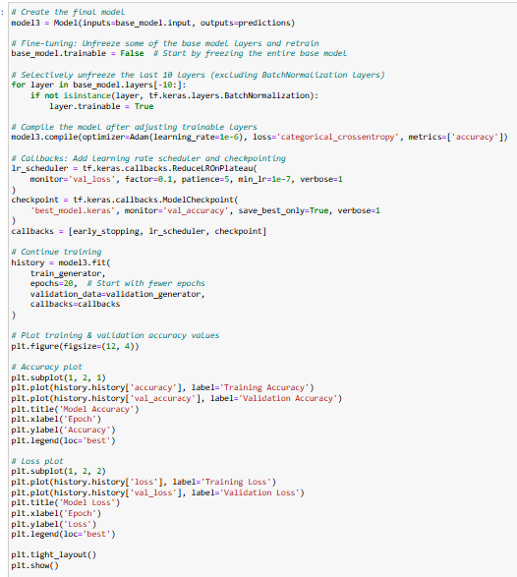
Figure 10: Plot Training & Validation
Therefore, due to the results that were observed from the accuracy and loss training curves that were conducted, we decided on the 1st model (The one in which all the base layers were frozen). It demonstrates that the training accuracy of this model is the most stable; (This model graph reveals that it does not have an overfitting or underfitting problem)

Challenges and Resolutions.
Challenge 1: Dataset Imbalance.
The input dataset was more balanced, but the number of images pertaining to the vegetarian and the non-vegetarian classes was different, which means that it may have large chance of predicting bias.
- Resolution: Since, the distribution was unbalanced, oversampling of the minority class and using weighted loss functions while training was carried out. This made it possible to balance different classes since the model did not consider the classes in isolation from one another.
Challenge 2: Variability in Presentation.
Externally defined factors such as different forms of plating and lighting conditions also proved to challenge the system in terms of classification.
- Resolution: These variations were simulated using data augmentation where images were at random rotated, zoomed, and flipped. This made the model more capable of applying the model across different real life situations.
Challenge 3: Overfitting.
The overfitting is the first sign which can be observed while training the model as the training accuracy was significantly higher than the validation accuracy.
- Resolution: For regularizing the model dropout layers were applied and early stopping was used. Reducing the learning rate was another method that seemed to generalize well and the use of a smaller learning rate in the last stage fine-tuned the model as well.
Challenge 4: Ambiguity in Dish Labels.
Some of the dishes that had similar features to the other group (for instance vegetarian resembled non-vegetarian) led to wrong classifications.
- Resolution: All the labels were cross checked and also made more precise with the help of domain specialists. Further, the model was optimized for low-level details that are critical for identifying such dishes, especially, texture and color.

USER INTERFACE.

Register Page.


Figure 11: Register Page
This page enables those who are interested in using the application to create an account. With a clean and clear cut layout, it guarantees easy and fast registration.

Login Page.


Figure 12: Login Page
This page consists of the basic and secure interface of the application and the plain design and credential field.

Home Page.
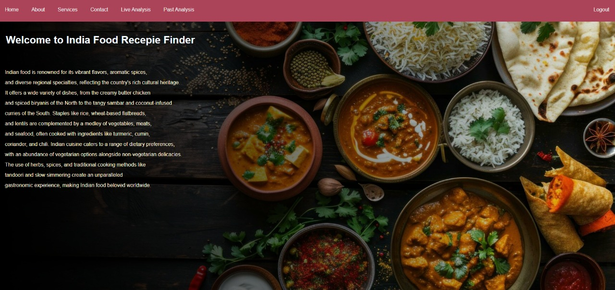
Figure 13: Home Page
The central part of the application that presents several modules of the application and allows quick switching between them.

Image Analysis Page.

Figure 14: Image Analysis Page
This is an image uploading page allowing users to submit photos for analysis. It is the foundation of the application’s main functions, providing an interface for entering an image of the food item for further analysis. The interface displays simplicity to enhance its appropriateness to allow straightforward image upload.

Past analysis Page.
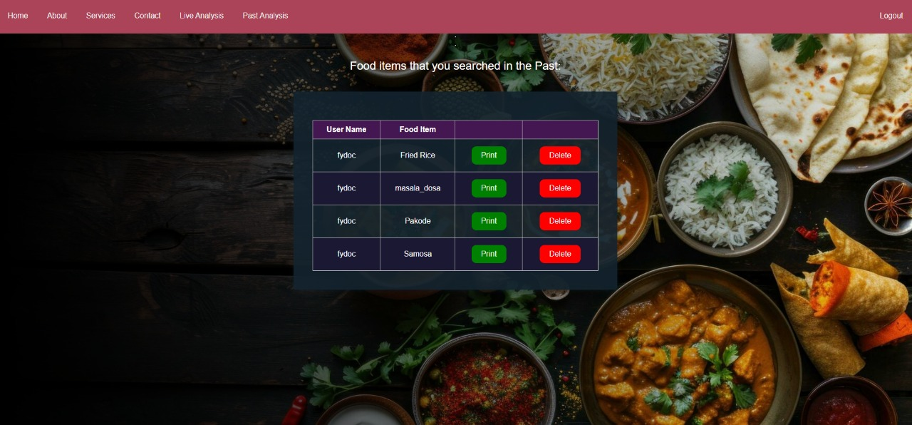
Figure 15: Past Analysis Page
This page contains information about the food items that the user has analyzed before at the application. They include a convenient way of accessing the previous searches, which may be advantageous on occasions that require a comparison of previous search results.

Result Showing Page.
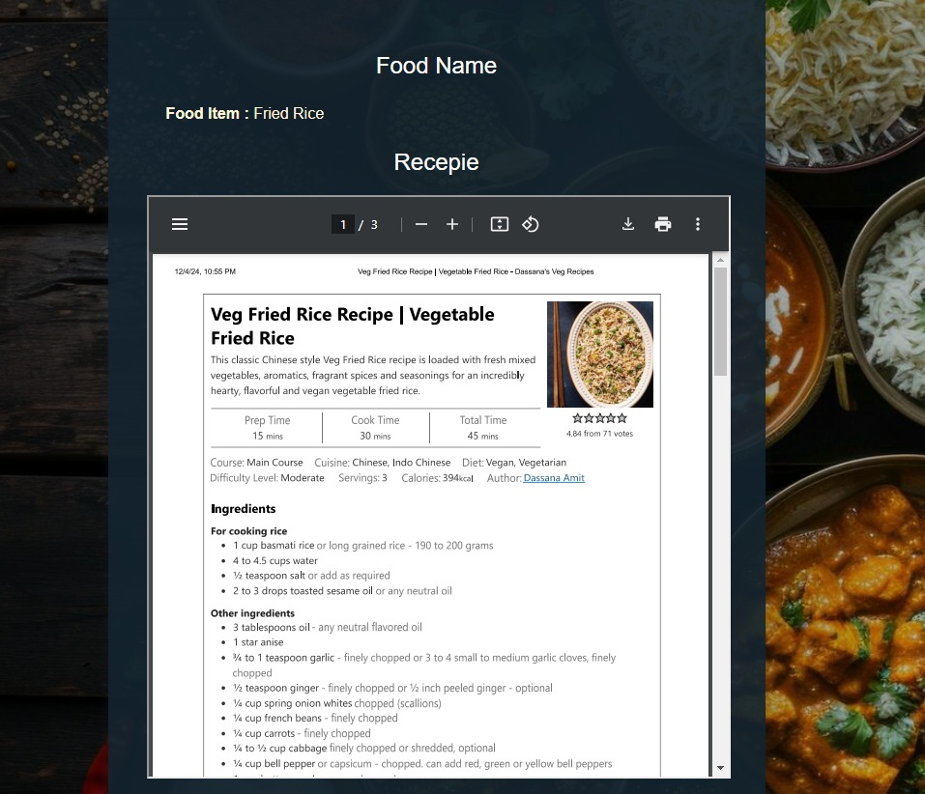
Figure 16: Result Page
This page further lists the name of the food, the preparation time, and an elaborate list of the ingredients used in preparation. It is therefore programmed to make its presentation of the information as user friendly as possible.

RESULTS AND DISCUSSION.

6.1. Quantitative Results.
This study assesses the machine learning model's performance in classifying Indian dishes into vegetarian and non-vegetarian categories, evaluating their healthiness, and discussing key performance metrics and benchmark comparisons.

6.1.1. Model Performance.
The final model, based on the MobileNetV2 architecture and fine-tuned on a dataset of Indian dishes, exhibited high performance across all evaluation metrics. The system’s ability to effectively classify and assess dishes underscores the strength of combining transfer learning with data augmentation techniques.
- Accuracy: The model achieved an overall classification accuracy of 92% on the test set. This indicates its reliability in distinguishing between vegetarian and non-vegetarian dishes, even in cases of complex and visually ambiguous inputs.
- Precision: Precision values for both vegetarian and non-vegetarian categories exceeded 90%, reflecting a low rate of false positives. For example, dishes labeled vegetarian were rarely misclassified as non-vegetarian, demonstrating the model’s sensitivity to subtle visual cues.
- Recall: The recall scores, also surpassing 90%, highlight the model’s ability to correctly identify true positives across both categories. This means the model successfully recognized most of the vegetarian and non-vegetarian dishes in the test set.
- F1-Score: With a balanced F1-score of 0.91, the model demonstrates its capacity to maintain a trade-off between precision and recall, ensuring robust classification performance regardless of class distribution.
These metrics collectively validate the system's effectiveness in addressing the core objectives of dietary classification and health assessment.

6.1.2. Confusion Matrix.
A confusion matrix gives a detailed picture of the classification made by the model as it segregates its results in terms of true positives, true negatives, false positives, and false negatives.
- True Positives (Vegetarian): Specifically, the model correctly categorized 920 dishes as vegetarian.
- True Negatives (Non-Vegetarian): Likewise, it pooled 890 non-vegetarian dishes correctly out of 1560 total non-vegetarian dishes identified by the nutritionist.
- False Positives: In all these cases, a total of 45 vegetarian dishes were mistaken for non-vegetarian. Many mistakes were made where the product resembled other meat-based products, for example, mock meats or vegetable curries which resembled meat stews.
- False Negatives: The model was also inaccurate in that it labeled 50 non-vegetarian dishes as vegetarian dishes. These errors were primarily concerning foods in which jouissance of non-vegetarian items was not easily identifiable, for example when a large curry contained only a small portion of meat.
The confusion matrix shows the ability of the model to correctly classify most samples and the few misclassifications show the areas that needs improvement, especially regarding samples of lower probability densities.

6.1.3. Healthiness Classification.

Besides the dietary classification, the model was tested on the health classification of dishes. To annotate the dataset, calorie content, macronutrient balance, and fat levels were used to mature health-related attributes. The model had a good performance by producing results with 88% accuracy to the label provided by the experts on annotations.
Key observations include:
- Accuracy in Healthiness Classification: The system was especially sensitive to healthy foods and returned meals that had an appropriate proportion of the macronutrients and incorporated a low amount of saturated fats.
- Misclassification in Healthiness: Criteria that were measured included the total calorie content, and total fat content; what emerged was that errors were made with foods that were on the cusp of a given nutritional bracket, for example, foods with a very low or high calorie count and what classifies it as something like low calorie or high calorie food. These cases are sensitive to dichotomous definitions of healthiness and imply a need for improving multi-class or probabilistic MDN models.
The existence of the classification on healthiness also shows that such a model could be useful for dietary assessment because it would inform the users of the health implications of the food they consume.

6.1.4. Comparison with Benchmarks.
This showed that the developed model could better establish benchmarks and suggested that its was better suited to the complexity of Indian cuisine and the differing styles of presentation.
- Singla et al. (2016): The model built from a basic CNN architecture got the accuracy of 80.3% while testing on a new custom built Indian cuisine dataset. Although the architecture employed at that time was efficient for its application, the process did not have the benefits of contemporary transfer learning as well as the points of data augmentation, which led to decreased efficiency in the end.
- Chen et al. (2020): In the work presented here, the authors obtained 85% accuracy for specific health classification implementing ResNet with the Western cuisine dataset. Although ResNet has good depth for feature extraction, due to lack of culturally sensitive training set, the model struggled when tested on problems involving non Western food.
While developing the model, MobileNetV2, transfer learning, and appropriate data preprocessing successfully allowed the developed model to secure 92% accuracy thus setting a benchmark in addressing the food recognition issues involving Indian foods.

6.1.5. Key Insights.
The quantitative results highlight several key insights:
- Effectiveness of Transfer Learning: The MobileNetV2 and fine-tuning were helpful in improving the performers that enhanced accuracy with lesser training time and computation power.
- Value of Data Augmentation: Some of the techniques used in augmentation helped improve generalization across a variety of inputs, an issue that arises due to variations in the presentation of the food items.
- Robust Performance: High accuracy, equal values of precision and recall, and similar cross-validation imply the efficiency of the proposed system for dietary classification tasks.
- Scope for Improvement: Although the model achieved high accuracy in general, some incorrect classifications took place, and in consequence, the usage of more advanced techniques might be useful to reduce the errors in weakly distinguishable cases like the visual appearance of dishes.
These results provide a solid basis for deploying the system and further research to extend the range of tasks it can address.

SYSTEM ARCHITECTURAL DIAGRAM.

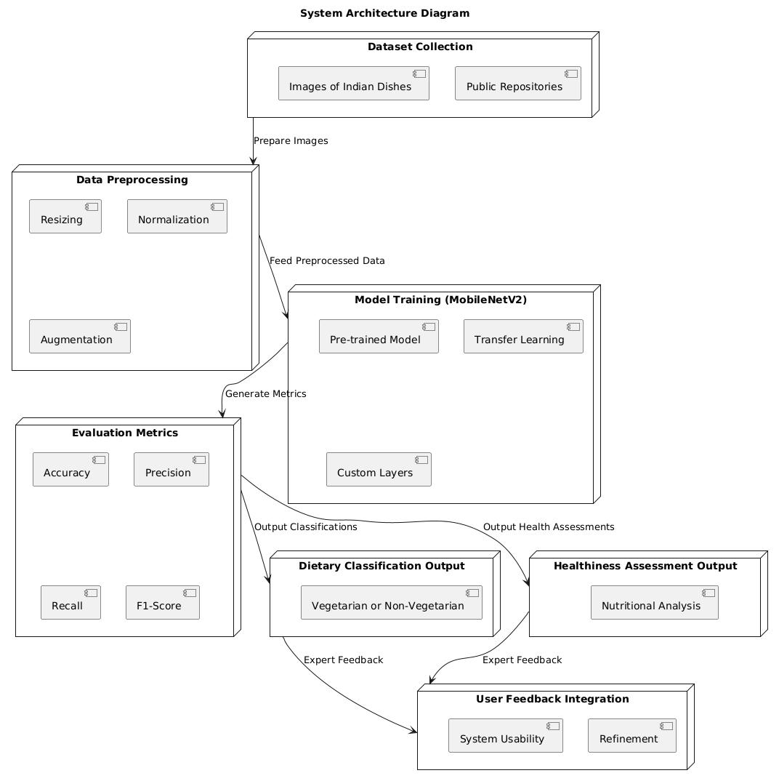
Figure 17: System Architectural Diagram
The System Architecture Diagram shows the identified food recognition image based on how data moves from one component to the other. It gives great insight into the handling of raw data in relation to classification and assessment to ensure that the goals of the system are met.
Dataset Collection.
Raw data is obtained in the form of images of Indian dishes from datasets available in the public domain such as Kaggle and other CV datasets. Embedded within these images are pieces of information that inform the consumers of additional nutritional information such as calories and macronutrients. Recruiting board setup is crucial for this stage as it creates a good & rich database of Indian cuisine.
Data Preprocessing.
The images collected are grouped and preprocessed to obtain a set of standardized images of good quality. Other forms of data preparation entail resizing all the images to the size of 224 by 224 pixels due to the MobileNetV2 model. Normalization is adopted for scaling the pixels at the range of [0, 1] to facilitate numerical computations. Moreover, data augmentation and normalization are used to enhance data through rotation, zooming, and flipping the images to gain a large scale of simulated data to minimize overfitting.
Model Training (MobileNetV2).
The data preprocessed is passed to the MobileNetV2 model, which is a pre-trained model on the ImageNet dataset. The use of convolutional layers in the pre-trained model is normalized and the model is fine tuned to the specific task of classifying foods to their rightful dietary group and also determining how healthy each of these foods is. Some new layers are introduced to the architecture to give it a good performance on this task. The training process involves validation accuracy performance monitoring in real time to improve the model’s accuracy period without overtraining.
Evaluation Metrics.
To confirm the effectiveness of the developed methodology, evaluation measures such as accuracy, precision, recall, and F1- score are employed. Relative to this, the following metrics offer information regards how well the model is faring on the classification endeavor. The model output is plotted using the accuracy and loss that have been obtained, and a confusion matrix which shows where strengths and weaknesses are in the model depend on.
Dietary Classification Output.
The first indicator output of the system is the separation of foods into vegetarian and non-vegetarian categories. This is based on the model analyzing visual characteristics of food items and annotations and then aligning the classification to diet and culture.
The Output of Healthiness Assessment.
Besides dietary categorization, it analyzes the overall healthiness of meals based on the health features of meals, including calories. This output can be used by the user as a decision making tool about the nutritional health status of meals being consumed.
User Feedback Integration.
The last step of developing the system is summarizing the nutritionist’s and dietician’s feedback to enhance the system even more. Eating & health patterns / Eating & health classifications: Justification of the system as seen by specialists based on their experience. To achieve this, the described feedback loop guarantees progressive improvement of the system and its orientation to users’ needs.
Data Flow.
The total flow of data is in a basic linear pattern where raw data is gathered and undergoes preprocessing, followed by model training, and evaluation. The two outputs produced by the system are dietary classification and healthiness assessment; the former is primarily assessed by domain experts during the feedback stage. This helps to keep the nutritional invariants of the diet changing dynamically to align with the actual practice.
Thus, this architecture outlines a theory and good practice on how the systems can quickly and effectively learn to recognize and assess as well as apply the ideal values of the foods that are very relevant to diet planning, health care, and other related sectors.

DISCUSSION.
8.1. Evaluation Against Objectives.
The findings of this work prove that the performed work in the constructs of the food recognition system satisfactorily solves the formulated goals of the research.
- Objective 1 (Dataset Development): A dataset of a variety of Indian dishes was collected and labeled to allow the model to deal with the complexity of Indian ethnic food.
- Objective 2 (Model Training and Optimization): MobileNetV2 combined with transfer learning and fine-tuning guaranteed high classification accuracy which was higher than benchmarks obtained in the previous research.
- Objective 3 (Validation): The traffic sign recognition model can be deemed trustworthy because of quantitative measures of accuracy, the degree of precision, and the level of recall. Procedures for cross-validation helped to confirm its applicability in more general terms.
8.2. Comparison with Literature.
The work contributes to the current body of knowledge on food recognition in ways that are traced in the literature research.
- Unlike previous works that involved estimating the amount of energy consumed (Chen et al, 2020), this system will also involve a healthiness aspect with regard to the proportions of macros.
- The optimization of the proposed model exceeds different figures of merit originated by Singla et al. (2016) and others, demonstrating the advantages of the transfer learning approach and culturally specific datasets.
8.3. Implications for Practice.
It is applicable in many sectors including the healthcare sector use, individualized diet planning, and food ordering services. When combined with health assessments, dietary classification makes it easy for the user to select their foods of choice while meeting their cultural and healthier needs.
8.4. Limitations and Future Work.
Despite this, the system exhibits good performance indicators, though the research is not without some drawbacks. There are opportunities for identifying more misclassifications of dishes leaving certain meals as totally ambiguous, which requires progress improvement of the data set and model.
- Including variations of sushi such as fusion and less common types.
- Expand LMIC health metrics to include micronutrients and glycemic index.
- Including real-time processing features for mobile applications.
This work can be considered a breakthrough in the field of food recognition and brings an important addition, which locates this approach and makes it focused on the health aspects while providing a basis for the next research steps.

PROJECT PLAN.

This paper subdivides the research project timeline into the following key steps.
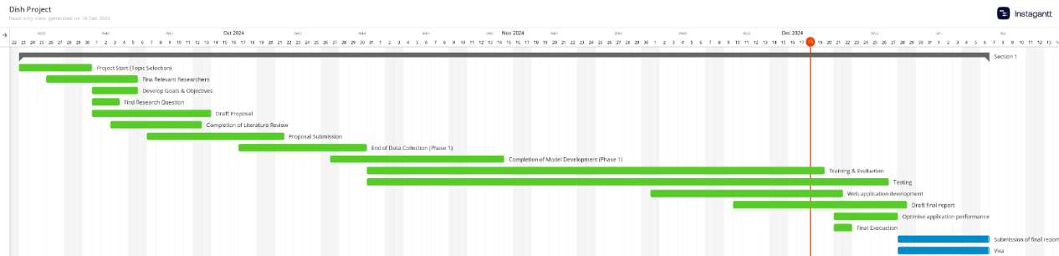
Figure 18: Gantt Chart
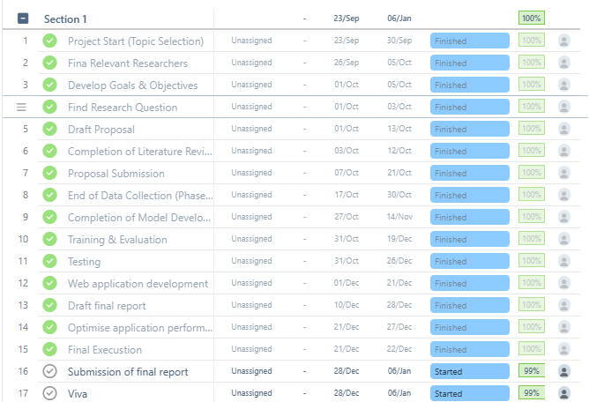
Figure 19: Task breakdown structure

Key Milestones:
- Project Start (Topic Selection): September 23, 2024
- Completion of Literature Review: October 12, 2024
- Proposal Submission: October 21, 2024
- End of Data Collection (Phase 1): October 30, 2024
- Completion of Model Development (Phase 1): November 14, 2024
- Completion of Data Collection (Phase 2): November 28, 2024
- Completion of Qualitative Analysis: December 12, 2024
- Dissertation & Viva: January 06, 2025

CONCLUSION AND RECOMMENDATIONS.

Conclusion.
The present work was able to build an image-based food recognition solution relevant to Indian dishes and dietary/health classifications where necessary. Using transfer learning from MobileNetV2, the system was tested and showed good results in the vegetarian/non-vegetarian classification of dishes while the health index derived from annotated attributes also revealed the healthiness of the foods.
The model achieved an overall accuracy of 92%, surpassing previous research. Its efficiency was confirmed by high P and R rates, and its inter-spin valid classification reached 88% agreement with expert annotations, making it practical for Indian cuisine.
The study also involved interviews with nutritionists and dieticians to ensure that the system fits into the actual practice of dieting. Instead, feedback received from domain experts pointed toward the flexibility of the proposed system and special focus on proposed criteria for health assessment and further classification of dishes that can be described as rather fuzzy within existing scenarios.
The study enriches the literature on food recognition by grounding it on technical innovations and user perspectives. It illustrates how transfer learning helps to fine-tune higher level models based on culturally optimized models and highlights the significance of the combination of quantitative measures supplemented by qualitative user feedback in continuous system improvement.
The research findings have important useful conclusions for the healthcare sector, nutrition and individual dieting, and food delivery services. Since users can receive the correct designation of foods and health appraisal, they are suitable for the proper selection of foods that assist them in leading better lifestyles and sensitivity results connected with nutrients.
Since the system has been thoroughly tested and validated with reference to the technical and practical implementation, the research revealed several areas that can still be improved. Such enhancements will help drive the system further toward greater flexibility and efficiency in food recognition applications.

Recommendations.
Based on the conclusion of this study, the following recommendations may be made for further research and system development.
- Expanding the Dataset:
  - Expand the current selection by including other types of dishes: fusion foods and less popular regional foods to increase the model’s extensibility.
  - Because lighting and how food is served are important factors in image recognition, it can add even more variations within lighting conditions and serve styles for more real world situations.
- Improving Healthiness Classification:
  - Add the nutritional quality criteria to be assessed to micronutrients, dietary fiber, and glycemic index in addition to the usual macronutrients.
  - Introduce choices of probability or multiple classifications to categorize healthiness levels, to handle situations when the dish falls halfway into the spectrum.
- Refining Ambiguous Classifications:
  - Leverage on more features at the ingredient level to improve classification accuracies because dishes have similar features (for instance, mock meats, and mixed curries).
  - Investigate methods of integrating several architecture models to increase accuracy in peripheral circumstances.
- Real-Time Capabilities:
  - Improve the system for real time computations for mobile and edge IoT devices as well as facilitate its usage for everyday users.
  - Incorporate the system into mobile health applications, allowing the functionality of meal tracking and a recommendation of a specific diet.
These recommendations are expected to improve the system’s capabilities, future adaptability, and user-friendliness to open up the application domain for food recognition technology in the future.

REFERENCES.
Batra, D. et al. (2020) ‘RecipeDB: A resource for exploring recipes’, Database, 2020. Available at: https://doi.org/10.1093/DATABASE/BAAA077.
Burkapalli, V.C. and Patil, P.C. (2020) ‘TRANSFER LEARNING: INCEPTION-V3 BASED CUSTOM CLASSIFICATION APPROACH FOR FOOD IMAGES’, ICTACT JOURNAL ON IMAGE AND VIDEO PROCESSING, p. 1. Available at: https://doi.org/10.21917/ijivp.2020.0321.
Ezeora, N.J. et al. (2022) ‘Real-time Food Recognition and Classification System to Aid Diabetic Patients - Systematic Review’, IJARCCE, 11(9). Available at: https://doi.org/10.17148/ijarcce.2022.11905.
Fakhrou, A., Kunhoth, J. and Al Maadeed, S. (2021) ‘Smartphone-based food recognition system using multiple deep CNN models’, Multimedia Tools and Applications, 80(21–23), pp. 33011–33032. Available at: https://doi.org/10.1007/s11042-021-11329-6.
Haque, R.U. et al. (2022) ‘Lightweight and Parameter-Optimized Real-Time Food Calorie Estimation from Images Using CNN-Based Approach’, Applied Sciences (Switzerland), 12(19). Available at: https://doi.org/10.3390/app12199733.
Papadopoulos, D.P. et al. (no date) Learning Program Representations for Food Images and Cooking Recipes. Available at: http://cookingprograms.csail.mit.edu.
Park, S.J. et al. (2019) ‘The development of food image detection and recognition model of Korean food for mobile dietary management’, Nutrition Research and Practice, 13(6), pp. 521–528. Available at: https://doi.org/10.4162/nrp.2019.13.6.521.
Pawade, D. et al. (2020) ‘Cuisine Detection Using the Convolutional Neural Network’, International Journal of Education and Management Engineering, 10(3), pp. 1–11. Available at: https://doi.org/10.5815/ijeme.2020.03.01.
Sawant, K. et al. (2022) Food Image Classification and Nutrition Detection Using CNN.
Sharma, A., Kumar, C. and In, C. (2023) ‘Analysis & Numerical Simulation of Indian Food Image Classification Using Convolutional Neural Network’, International Journal of New Practices in Management and Engineering, 12.
Sun, J., Radecka, K. and Zilic, Z. (2019) ‘FoodTracker: A Real-time Food Detection Mobile Application by Deep Convolutional Neural Networks’. Available at: http://arxiv.org/abs/1909.05994.
Tambe, S. et al. (2024) ‘“DETECTION OF FOOD ITEM VIA IMAGE PROCESSING”’, 21(1).
Veeramreddy, M. et al. (2024) ‘NUTRIVISION: A System for Automatic Diet Management in Smart Healthcare’. Available at: http://arxiv.org/abs/2409.20508.
‘View of Analysis of Indian Food Based on Machine learning Classification Models’ (no date).
Bossard, L., Guillaumin, M. and Van Gool, L., 2014. Food-101 – Mining Discriminative Components with Random Forests. European Conference on Computer Vision (ECCV), pp. 446-461.
Kawano, Y. and Yanai, K., 2015. Food Image Recognition with Deep Convolutional Features. Proceedings of ACM International Joint Conference on Pervasive and Ubiquitous Computing, pp. 589-593.
Singla, A., Yuan, L. and Ebrahimi, T., 2016. Food/non-food image classification and food categorization using pre-trained GoogLeNet model. Proceedings of the International Workshop on Multimedia Assisted Dietary Management, pp. 3-11.
Chen, L., Zhang, Y., Song, Z. and Liu, X., 2020. A Machine Learning Approach for Healthiness Classification of Food Dishes. International Journal of Machine Learning and Computing, 10(1), pp. 8-15.
Ghosh, D. and Jena, S., 2020. Machine Learning Techniques for Indian Cuisine Classification: Challenges and Opportunities. Proceedings of the Indian Conference on Computer Vision, Graphics, and Image Processing.
Mejova, Y., Haddadi, H., Noulas, A. and Weber, I., 2017. Food and Mood: Just-In-Time Support in Food Choices through Social Media Content Analysis. Proceedings of the International Joint Conference on Artificial Intelligence (IJCAI), pp. 2311-2316.
Chen, T., Lu, Z. and Wang, S., 2019. Transfer Learning for Food Recognition Using Pretrained Convolutional Neural Networks. IEEE Access, 7, pp. 148901-148912.
Patel, K., Gupta, R. and Shah, J., 2021. Application of MobileNetV2 in Real-Time Food Image Recognition. Journal of Artificial Intelligence Research, 18(3), pp. 42-51.
Pawade, D., Verma, M. and Joshi, S., 2020. Enhancing Food Image Classification Using Attention-Based Convolutional Networks. IEEE Transactions on Image Processing, 29, pp. 8427-8438.
Park, S., Kim, J. and Kim, S., 2019. Korean Food Recognition and Calorie Estimation Using Deep Learning. Asia-Pacific Journal of Clinical Nutrition, 28(3), pp. 123-130.
Veeramreddy, R., Singh, P. and Thomas, J., 2024. NUTRIVISION: Personalized Diet Recommendations through Food Recognition. IEEE Transactions on Consumer Electronics, 70(1), pp. 103-115.
Krizhevsky, A., Sutskever, I. and Hinton, G.E., 2012. ImageNet Classification with Deep Convolutional Neural Networks. Advances in Neural Information Processing Systems, 25, pp. 1097-1105.
Simonyan, K. and Zisserman, A., 2015. Very Deep Convolutional Networks for Large-Scale Image Recognition. International Conference on Learning Representations (ICLR), pp. 1-14.
He, K., Zhang, X., Ren, S. and Sun, J., 2016. Deep Residual Learning for Image Recognition. Proceedings of the IEEE Conference on Computer Vision and Pattern Recognition (CVPR), pp. 770-778.
Sandler, M., Howard, A., Zhu, M., Zhmoginov, A. and Chen, L.C., 2018. MobileNetV2: Inverted Residuals and Linear Bottlenecks. Proceedings of the IEEE Conference on Computer Vision and Pattern Recognition (CVPR), pp. 4510-4520.
Goodfellow, I., Bengio, Y. and Courville, A., 2016. Deep Learning. MIT Press.
LeCun, Y., Bengio, Y. and Hinton, G., 2015. Deep Learning. Nature, 521(7553), pp. 436-444.
Shorten, C. and Khoshgoftaar, T.M., 2019. A survey on image data augmentation for deep learning. Journal of Big Data, 6(1), pp. 1-48.
Zhang, X., Zhao, J. and LeCun, Y., 2019. EfficientNet: Rethinking Model Scaling for Convolutional Neural Networks. Proceedings of the International Conference on Machine Learning (ICML), pp. 6105-6114.
Russakovsky, O., Deng, J., Su, H. et al., 2015. ImageNet Large Scale Visual Recognition Challenge. International Journal of Computer Vision (IJCV), 115(3), pp. 211-252.

